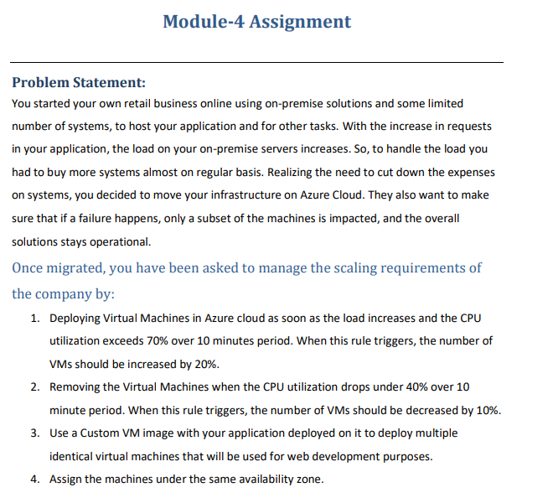

**Step 1**:-We will have VM Scale set for this

On Basics tab we have to provide details like VM name ,Region,Avaliability Zone, Image and size

On Disks tab we will have by default disk created by azure if we want we create one more disk.

On Networking tab we have select virtual network and Load balancer (for distribute the load between the VMs)

On scaling tab we have to provide Scale out and Scale In criteria by custom scaling policy.

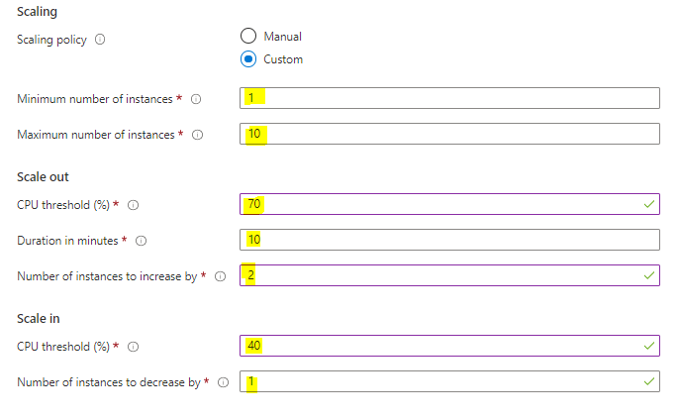

After Creating VMSS we have to select the scaling and provide the Action rule in percentage for **scale out** (Requirement:-If utilization exceeds 70% over 10 minutes period if this rule triggers, the number of VMs should be increased by 20%)

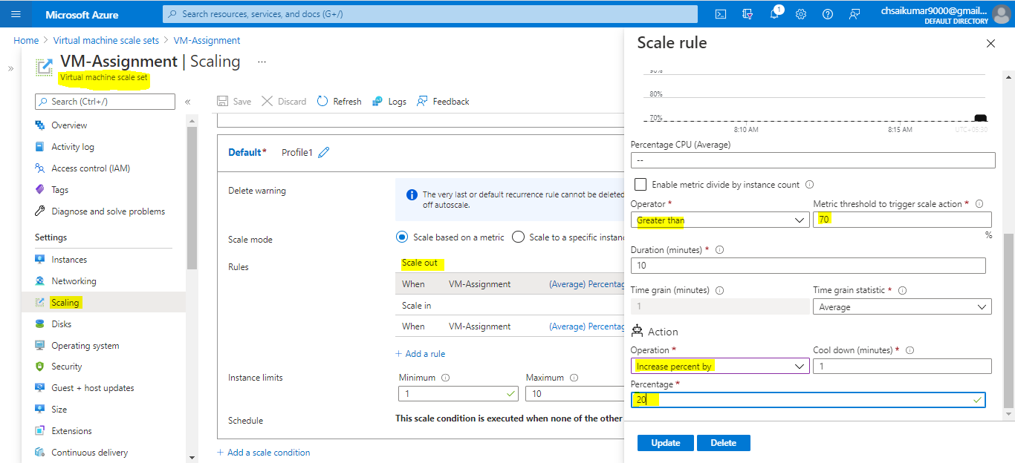

Action rule in percentage for **scale in** (Requirement:-If utilization drops under 40% over 10 minutes period if this rule triggers, the number of VMs should be increased by 10%)

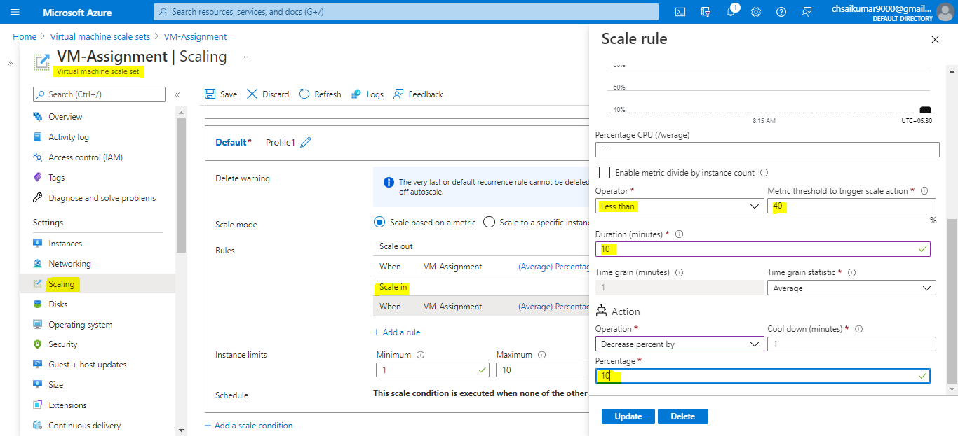

**Step 3**:- We have to create One VM with LINUX OS and install Apache2 on that VM.

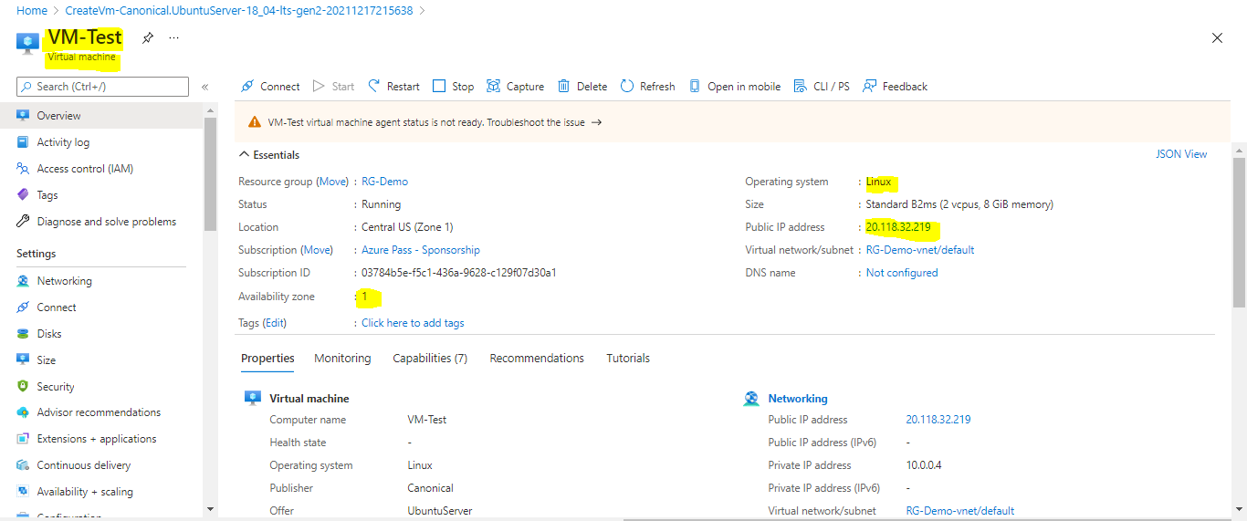

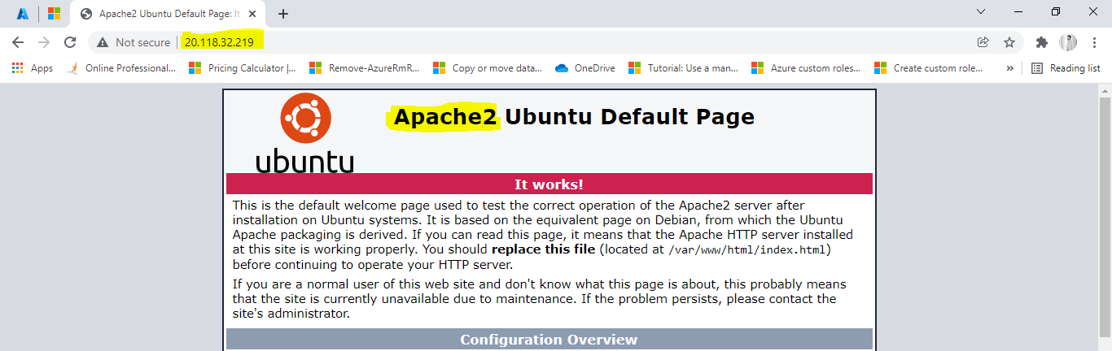

After installing Apache2 to Create custom image from the VM we have to give sudo waagent deprovision+user to clear the secturity ID. 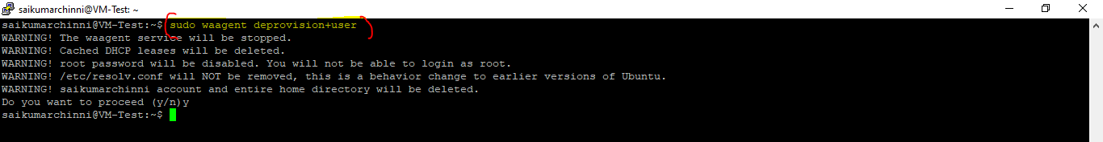

**Step 4**:- Successfully created a custom image we have to create a VM from that image.While creating the VM we have to assign the VM to same zone.

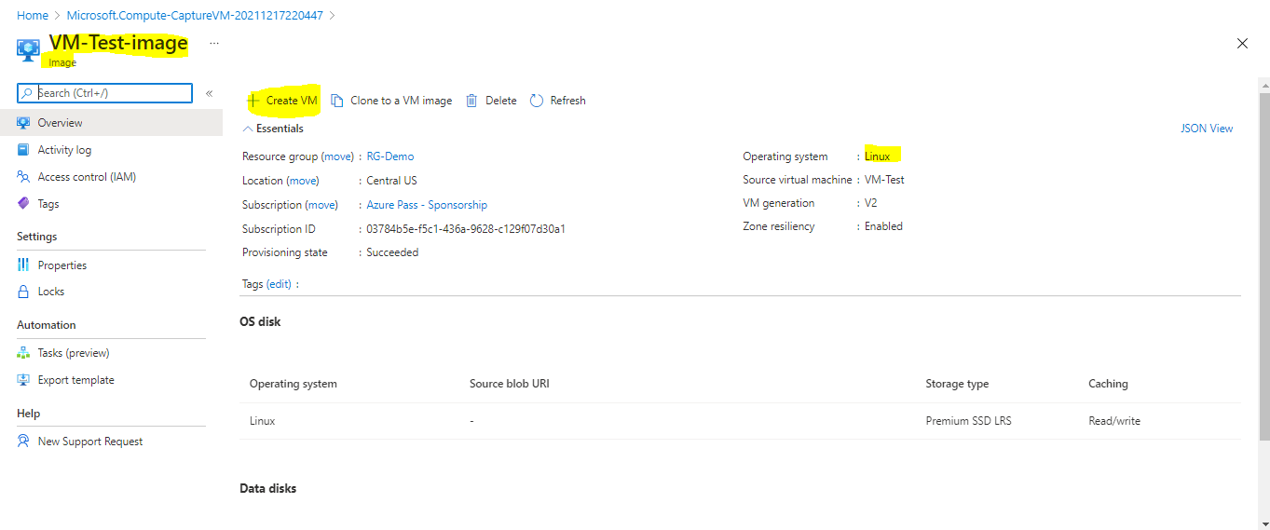

After succesful creation of VM from custom image we can directly copy the IP address from the VM and search for that we can see the Apache2 website.

